**APA Formatting Study**

Fangji Chen

Georgian College

AIDI 1004 - Issues & Challenges in AI

Katie Tiwari

September 18, 2022

**APA Formatting Study**

1. **Why use APA Style?**

It guides people through the scholarly writing process, for example in-text citations and references. Following this guidance may help people disclose resources and avoid plagiarism.

1. **What four elements do most references contain?**

The elements should contain:

Authors of work

Date of work

title of work

source of work

1. **What elements are required on an APA Style student title page? Provide an example using the information for this course.**

A student title page requires elements as below:

title of paper

author names

author affiliation

course number and name for which the paper is being submitted

instructor name

assignment due date

page number

Here is the example retrived from the Apastype website:

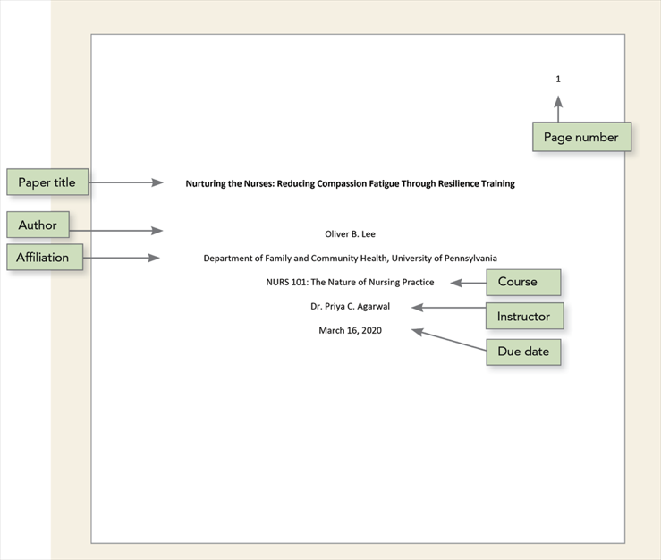

1. **What line spacing should you use for all text in an APA Style paper?**

Double space

1. **What paragraph alignment and paragraph indentation should you use for all text in an APA Style paper?**

Alignment: left margin

Indentation: use first line indentation of 0.5 inch for each paragraph

1. **How many heading levels is it possible to use in the text of an APA Style paper?**

5 levels

1. **Which heading levels are written in bold? Which heading levels are written in bold italic?**

All the 5 levels of heading are written in Bold format.

1. **What should you write on the first line on the first page of text in all APA Style papers?**

Write paper title again in the same format as in the title page.

1. **In general, what numbers are expressed in words and what numbers are expressed in numerals in an APA Style paper?**

In general, use numerals to express numbers 10 and above, and use words to express numbers zero through nine in APA Style paper.

1. **When citing multiple works by different authors in parentheses, in what order should you place the citations? What punctuation mark should you use between the citations?**

When more than one works are going to be citing in one in-text citation, using alphabetical order to list them and separating them with semicolons.

1. **When citing multiple works by the same author in parentheses, how many times should you write the author’s name? In what order should you place the citations? What punctuation mark should you use between the citations?**

Arrange two or more works by the same authors by year of publication.

Place citations with no date first.

Then, order works with dates in chronological order.

Place in-press citations last.

Give the authors’ surnames once; for each subsequent work, give only the date.

1. **When a work has three or more authors, what is the correct format to use for the authors’ names in the in-text citation?**

Use the first author plus “et al.” in an in-text citation if there are three or more authors.

1. **What does it mean to paraphrase versus directly quote from a work?**

Paraphrasing means restate original ideas from the article, and quotation means copy original text from source.

1. **What is the maximum length (number of words) of a short quotation (i.e., a quotation that is placed in double quotation marks within the text of a sentence)?**

Less than 40 words.

1. **What format should you use for a quotation of 50 words?**

Use block quotations for quotations with 40 words or more.

1. **What should you write instead of a date in a reference for a work with no date?**

use “n.d.” in the in-text citation.

1. **How do you format an APA Style reference list? Specify its location within the text, including whether it should begin on a new page, the label it should have, and the linespacing and paragraph indentation to use. Provide an example using the reference to answer this question.**

The answer will be shown in **References** in next page.

**References**

About APA style. (2022, March). Apastyle. Retrieved September 18, 2022, from [**https://apastyle.apa.org/about-apa-style**](https://apastyle.apa.org/about-apa-style)

Archival documents and collections. (2019, September). Apastyle. Retrieved September 18, 2022, from [**https://apastyle.apa.org/style-grammar-guidelines/references/archival**](https://apastyle.apa.org/style-grammar-guidelines/references/archival)

Author–date citation system. (2019, September). Apastyle. Retrieved September 18, 2022, from [**https://apastyle.apa.org/style-grammar-guidelines/citations/basic-principles/author-date**](https://apastyle.apa.org/style-grammar-guidelines/citations/basic-principles/author-date)

Citing multiple works. (2022, August). Apastyle. Retrieved September 18, 2022, from [**https://apastyle.apa.org/style-grammar-guidelines/citations/basic-principles/multiple-works**](https://apastyle.apa.org/style-grammar-guidelines/citations/basic-principles/multiple-works)

Headings. (2022, July). Apastyle. Retrieved September 18, 2022, from [**https://apastyle.apa.org/style-grammar-guidelines/paper-format/headings**](https://apastyle.apa.org/style-grammar-guidelines/paper-format/headings)

Line paragraph alignment and indentation. (2022, July). Apastyle. Retrieved September 18, 2022, from [**https://apastyle.apa.org/style-grammar-guidelines/paper-format/paragraph-format**](https://apastyle.apa.org/style-grammar-guidelines/paper-format/paragraph-format)

Line spacing. (2022, July). Apastyle. Retrieved September 18, 2022, from [**https://apastyle.apa.org/style-grammar-guidelines/paper-format/line-spacing**](https://apastyle.apa.org/style-grammar-guidelines/paper-format/line-spacing)

Numbers expressed in numerals. (2022, July). Apastyle. Retrieved September 18, 2022, from [**https://apastyle.apa.org/style-grammar-guidelines/numbers/numerals**](https://apastyle.apa.org/style-grammar-guidelines/numbers/numerals)

Numbers expressed in words. (2022, July). Apastyle. Retrieved September 18, 2022, from [**https://apastyle.apa.org/style-grammar-guidelines/numbers/words**](https://apastyle.apa.org/style-grammar-guidelines/numbers/words)

Paraphrasing. (2022, July). Apastyle. Retrieved September 18, 2022, from [**https://apastyle.apa.org/style-grammar-guidelines/citations/paraphrasing**](https://apastyle.apa.org/style-grammar-guidelines/citations/paraphrasing)

Quotations. (2022, July). Apastyle. Retrieved September 18, 2022, from [**https://apastyle.apa.org/style-grammar-guidelines/citations/quotations**](https://apastyle.apa.org/style-grammar-guidelines/citations/quotations)

Sample papers. (2022, July). Apastyle. Retrieved September 18, 2022, from [**https://apastyle.apa.org/style-grammar-guidelines/paper-format/sample-papers**](https://apastyle.apa.org/style-grammar-guidelines/paper-format/sample-papers)

Title page setup. (2022, July). Apastyle. Retrieved September 18, 2022, from [**https://apastyle.apa.org/style-grammar-guidelines/paper-format/title-page**](https://apastyle.apa.org/style-grammar-guidelines/paper-format/title-page)